PIZZA SALES SQL QUERIES
KPI’s
- Total Revenue:
SELECT SUM(total_price) AS Total_Revenue FROM pizza_sales;
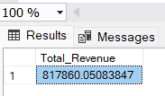
- Average Order Value:
SELECT (SUM(total_price) / COUNT(DISTINCT order_id)) AS Avg_order_Value FROM pizza_sales
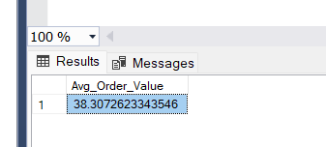
- Total Pizzas Solds
SELECT SUM(quantity) AS Total_pizza_sold FROM pizza_sales
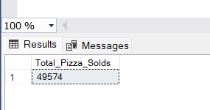
- Total Orders :
SELECT COUNT(DISTINCT order_id) AS Total_Orders FROM pizza_sales
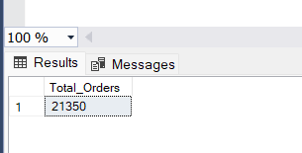
- Average Pizza Per Order
SELECT CAST(CAST(SUM(quantity) AS DECIMAL(10,2)) /
CAST(COUNT(DISTINCT order_id) AS DECIMAL(10,2))AS DECIMAL(10,2))AS Avg_Pizzas_per_order FROM pizza_sales;
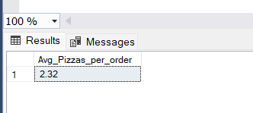

PROBLEM STATEMENT
CHART REQUIREMENT
- Daily Trend for Total Orders
SELECT DATENAME(DW, order_date) AS order_day, COUNT(DISTINCT order_id) AS total_orders
FROM pizza_sales
GROUP BY DATENAME(DW, order_date)
Output:
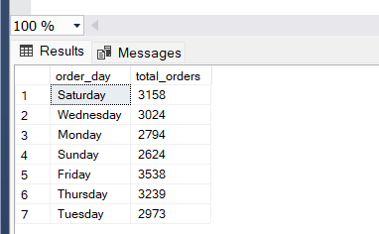

- Monthly Trends for Total Orders:
select datename(month,order_date) as Month_Name ,count(distinct order_id)as Total_order
from pizza_sales
group by datename(month,order_date);
Or
select datename(month,order_date) as Month_Name ,count(distinct order_id)as Total_order
from pizza_sales
group by datename(month,order_date)
order by Total_order desc;

Output:
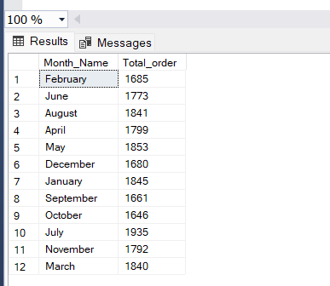
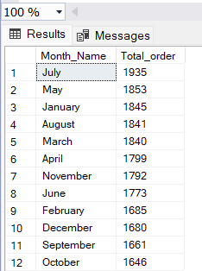

- Percentage of Sales by Pizza Category:
SELECT pizza_category, CAST(SUM(total_price) AS DECIMAL(10,2)) as total_revenue,
CAST(SUM(total_price) * 100 / (SELECT SUM(total_price) from pizza_sales) AS DECIMAL(10,2)) AS PCT
FROM pizza_sales
GROUP BY pizza_category
Output:
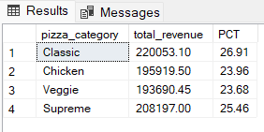
OR
SELECT pizza_category, CAST(SUM(total_price) AS DECIMAL(10,2)) as total_revenue,
CAST(SUM(total_price) * 100 / (SELECT SUM(total_price) from pizza_sales WHERE MONTH (order_date) = 1) AS DECIMAL(10,2)) AS PCT
FROM pizza_sales
WHERE MONTH (order_date) = 1
GROUP BY pizza_category
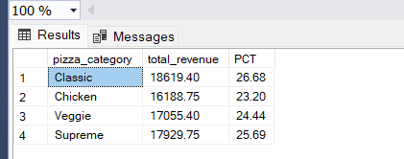
- Percentage of sales by Pizza Size :
SELECT pizza_size, CAST(SUM(total_price) AS DECIMAL(10,2)) as total_revenue,
CAST(SUM(total_price) * 100 / (SELECT SUM(total_price) from pizza_sales) AS DECIMAL(10,2)) AS PCT
FROM pizza_sales
GROUP BY pizza_size
ORDER BY PCT;
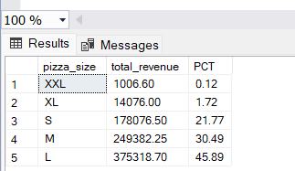
OR
SELECT pizza_size, CAST(SUM(total_price) AS DECIMAL(10,2)) as total_revenue,
CAST(SUM(total_price) * 100 / (SELECT SUM(total_price) from pizza_sales WHERE DATEPART(quarter,order_date) = 1) AS DECIMAL(10,2)) AS PCT
FROM pizza_sales
WHERE DATEPART(quarter,order_date) = 1
GROUP BY pizza_size
ORDER BY PCT;
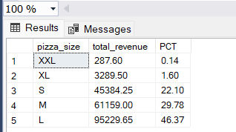

5.Total Pizzas Sold by Pizzas Category
SELECT pizza_category, SUM(quantity) as Total_Quantity_Sold
FROM pizza_sales
WHERE MONTH(order_date) = 2
GROUP BY pizza_category
ORDER BY Total_Quantity_Sold DESC
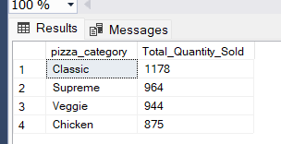

6.Top 5 Pizaa by revenue
SELECT Top 5 pizza_name, SUM(total_price) AS Total_Revenue
FROM pizza_sales
GROUP BY pizza_name
ORDER BY Total_Revenue DESC
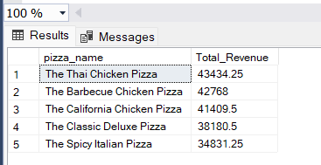

7.Bottom 5 Best seller by revenue
SELECT Top 5 pizza_name, SUM(total_price) AS Total_Revenue
FROM pizza_sales
GROUP BY pizza_name
ORDER BY Total_Revenue ASC
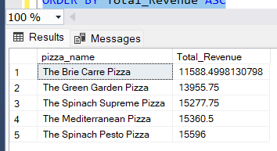

8.Top 5 Pizzas by Category
SELECT Top 5 pizza_name, SUM(quantity) AS Total_Pizza_Sold
FROM pizza_sales
GROUP BY pizza_name
ORDER BY Total_Pizza_Sold DESC
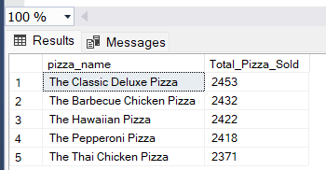

9. Bottom 5 Pizza by Quantity
SELECT Top 5 pizza_name, SUM(quantity) AS Total_Pizza_Sold
FROM pizza_sales
GROUP BY pizza_name
ORDER BY Total_Pizza_Sold ASC
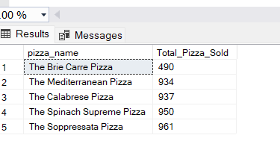

10. Top 5 Pizza by Total Order
SELECT Top 5 pizza_name, COUNT(DISTINCT order_id) AS Total_Orders
FROM pizza_sales
GROUP BY pizza_name
ORDER BY Total_Orders DESC
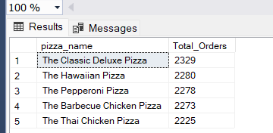

11. Bottom 5 Pizzas by total orders
SELECT Top 5 pizza_name, COUNT(DISTINCT order_id) AS Total_Orders
FROM pizza_sales
GROUP BY pizza_name
ORDER BY Total_Orders asc
